PYTHGORAS THEOREM
Pearson Edexcel - Tuesday 11 June 2019 - Paper 3 (Calculator) Higher Tier
1.
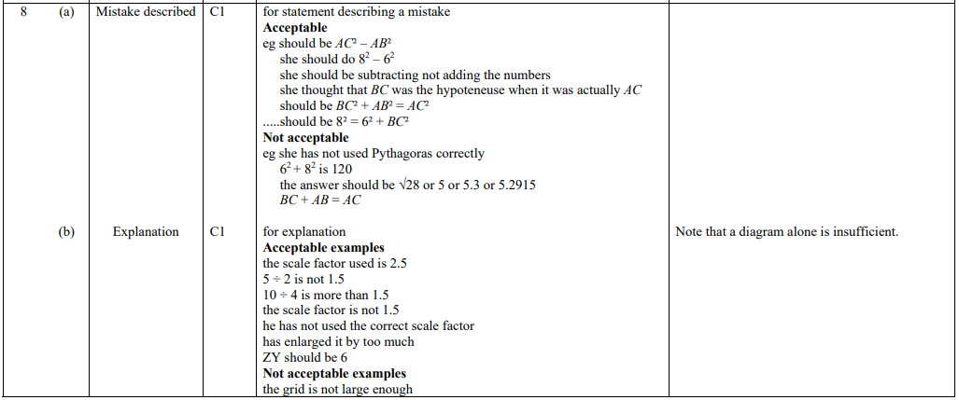
Pearson Edexcel - Thursday 25 May 2017 - Paper 1 (Non-Calculator) Higher Tier
2.
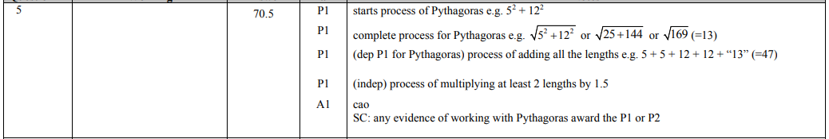
Pearson Edexcel - Specimen Papers Set 2 - Paper 1 (Non-Calculator) Higher Tier
3.
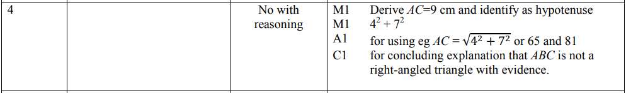
Pearson Edexcel - Friday 6 November 2015 - Paper 2 (Calculator) Higher Tier
4.
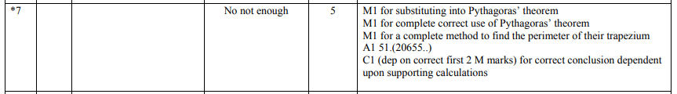
Pearson Edexcel - Friday 8 November 2013 - Paper 2 (Calculator) Higher Tier
5.
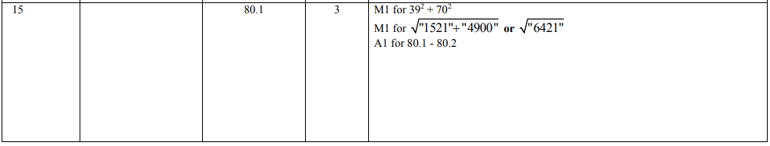
Pearson Edexcel - Friday 14 June 2013 - Paper 2 (Calculator) Higher Tier
6.
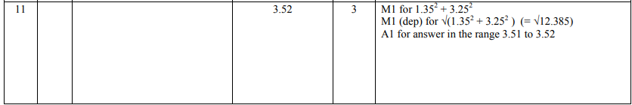
Pearson Edexcel - Monday 4 March 2013 - Paper 2 (Calculator) Higher Tier
7.
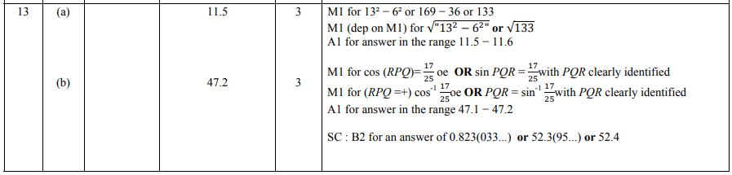
Pearson Edexcel - Friday 2 March 2012 - Paper 3 (Non-Calculator) Higher Tier
8.
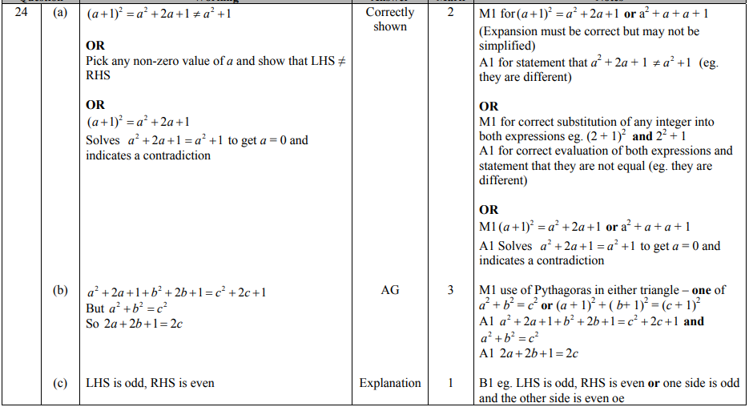
Pearson Edexcel - Wednesday 9 November 2011 - Paper 3 (Non-Calculator) Higher Tier
9.
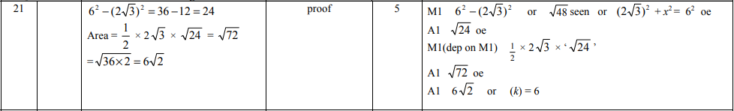
Pearson Edexcel - Tuesday 9 November 2010 - Paper 3 (Non-Calculator) Higher Tier
10.
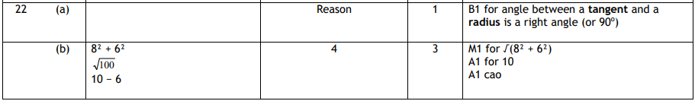
Pearson Edexcel - Monday 7 June 2010 - Paper 3 (Non-Calculator) Higher Tier
11.
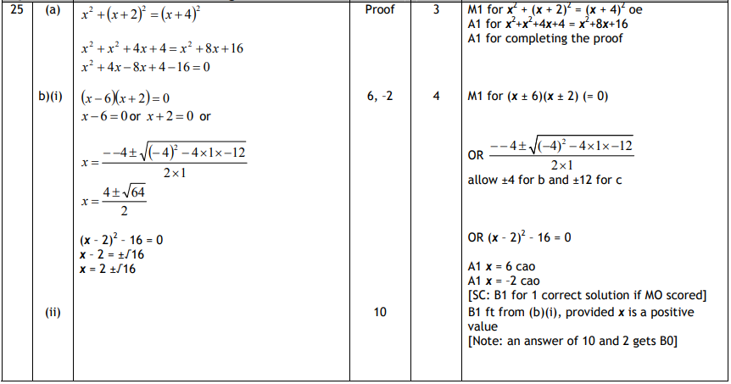
Pearson Edexcel - Tuesday 10 November 2009 - Paper 4 (Calculator) Higher Tier
12.
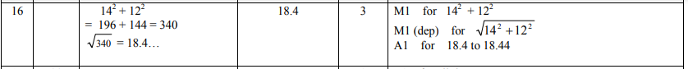
OCR GSCE – Tuesday 6 November 2018 – Paper 4 (Calculator) Higher Tier
13.
AQA GSCE – Thursday 8 June 2020 – Paper 3 (Calculator) Higher Tier
14.
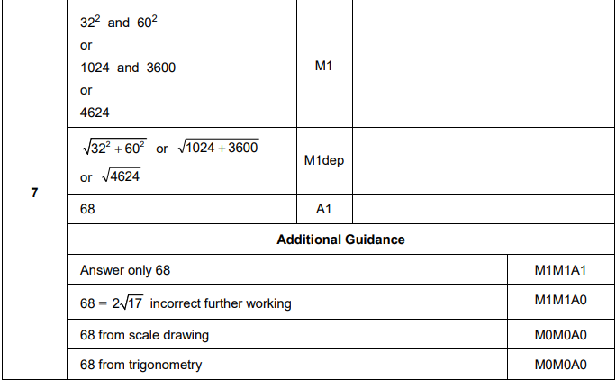
AQA GSCE – Tuesday 12 June 2018 – Paper 3 (Calculator) Higher Tier
15.
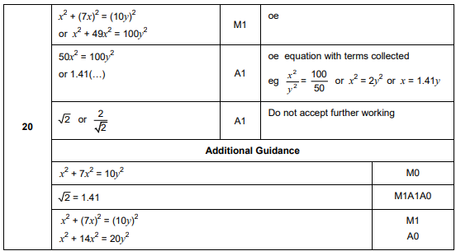

AQA GSCE – Thursday 8 June 2017 – Paper 2 (Calculator) Higher Tier
16.
